**Issue**

The details from RDC( After the repull ) Its not flowing to SC

No error seen in logs

the Account Hierarchy data is missing on the account and users are not able to create opportunities >> For this they get Orphan client error

[$5B2946674981FD29.jpg]

**RCA**

When we verified the sfa_status in sctid.accounts table using below we found there were 145 records where sfa_status was NULL or blank.

select ccms_id from sme.accounts where ccms_level='S' and (sfa_status is NULL or trim(sfa_status)='') and deleted=0

The castiron orchestration RDcUnqualifiedSiteController was spewing one error as below

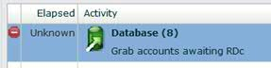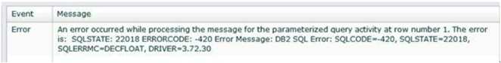

That was because the sfa_status had NULL or blank per above sql result  
Below is the sql used by the orchestration which was failing

SELECT NAME, ID, DATE_MODIFIED, DATE_ENTERED, SFA_STATUS

FROM ACCOUNTS WHERE CCMS_LEVEL = 'S' and

((((SFA_STATUS LIKE '1%' and SFA_STATUS!='10' AND SFA_STATUS!='1') OR SFA_STATUS LIKE '3%' OR SFA_STATUS LIKE '6%' ) AND DELETED = 0 )

or (SFA_STATUS LIKE '7%' AND DELETED = 1))

AND (SFA_STATUS < 10 or mod(SFA_STATUS, 10) < ?)

ORDER BY DATE_ENTERED DESC

FETCH FIRST 5000 ROWS ONLY UPDATE

**Solution**

We run the below 2 sqls to update the SFA_status as per Tony’s suggestions:  
Update SCTID.ACCOUNTS SET SFA_STATUS =5 WHERE ID IN (select ID from sme.accounts where ccms_level='S' and (sfa_status is NULL or trim(sfa_status)='') and deleted=0 )

UPDATE SCTID.ACCOUNTS_CSTM SET LAST_UPDATING_SYSTEM_C ='SFA_FIX' WHERE ID_C IN (select ID from sme.accounts where ccms_level='S' and (sfa_status is NULL or trim(sfa_status)='') and deleted=0 )   
  
**And then everything started working and the castiorn pulled the data from RDC.**